ELITE SERIES OVEN CURE

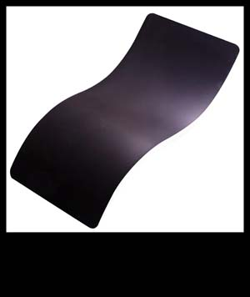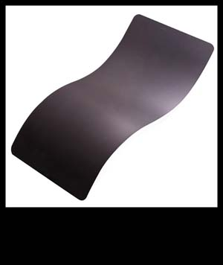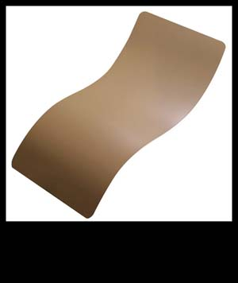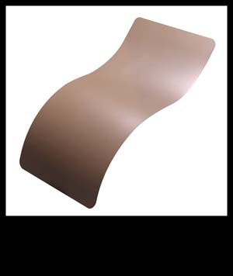
MIDNIGHT SMOKE 20150 COYOTE
E-120Q E-120Q E-190Q E-130Q

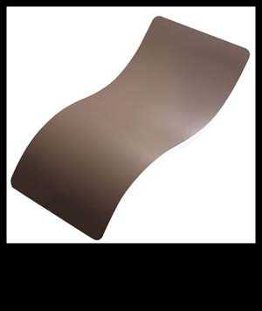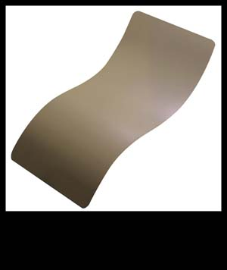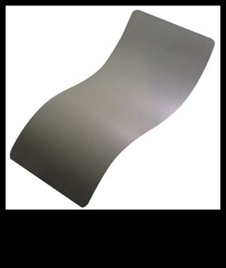
EARTH SAND JUNGLE SMOKE
E-130Q E-150Q E-140Q E-120Q

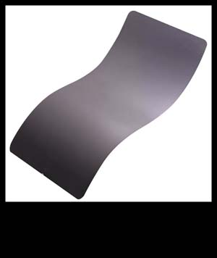
CONCRETE
E-160Q

CERAMIC SERIES OPTIONS

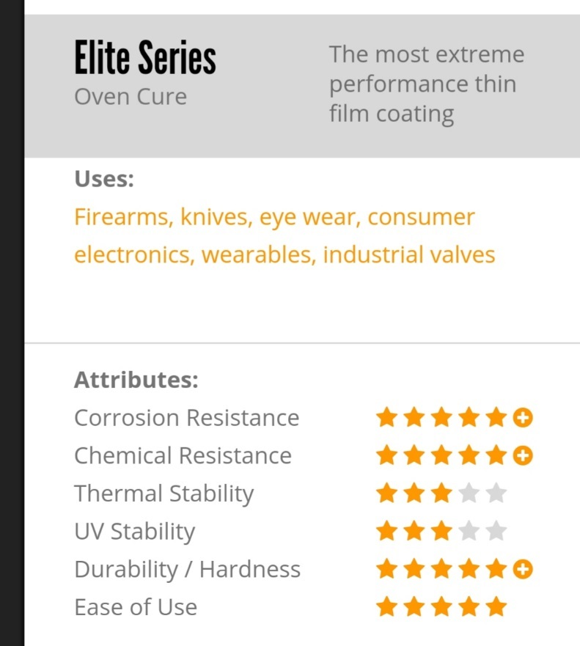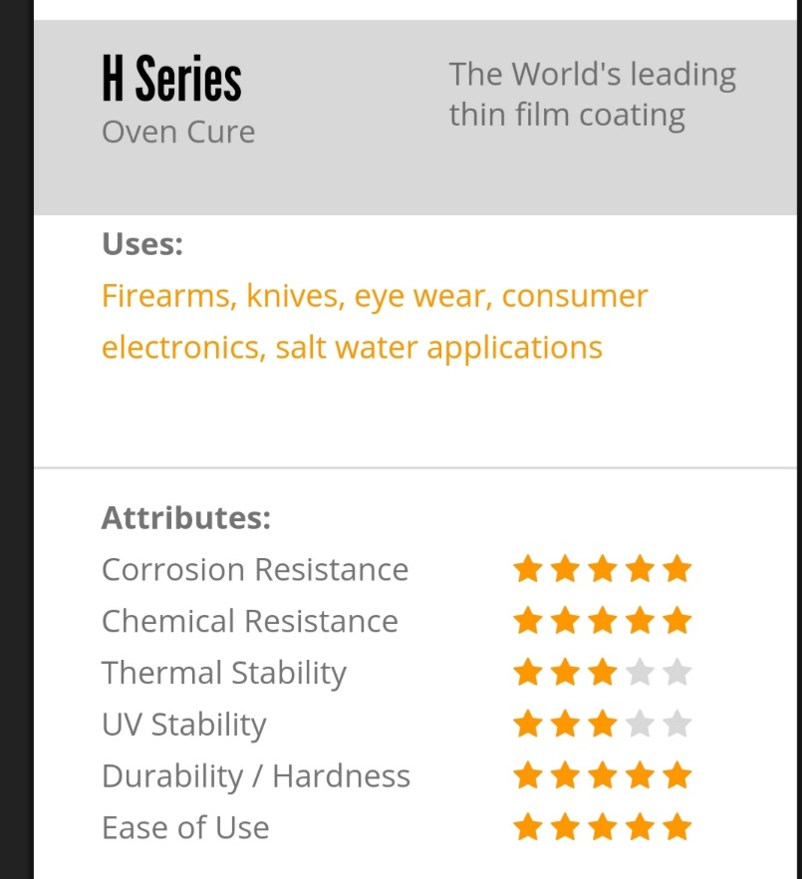

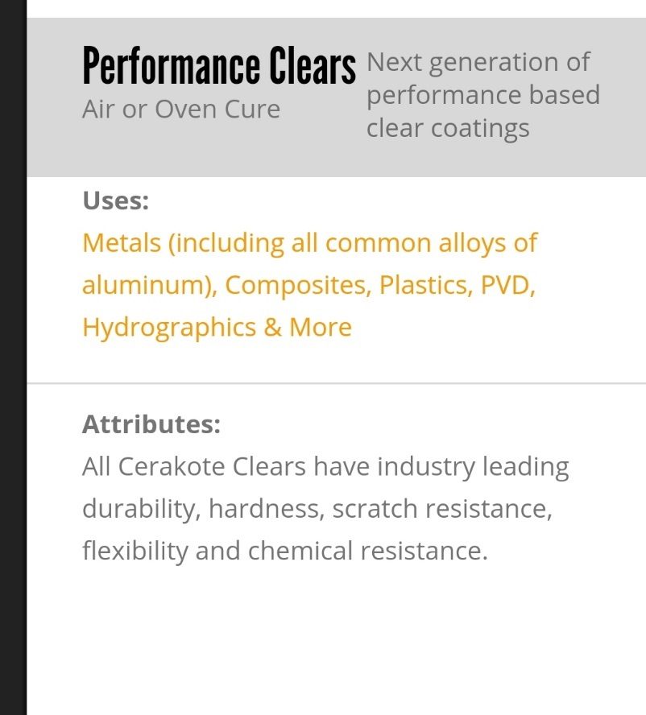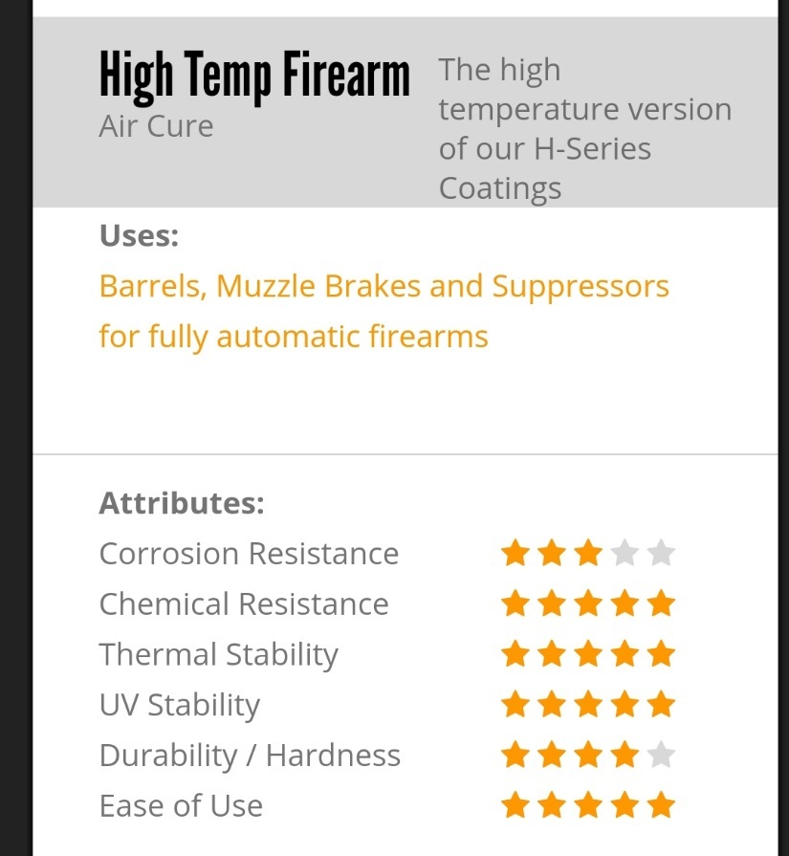

H-SERIES OVEN CURE
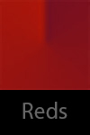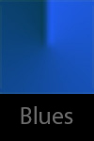

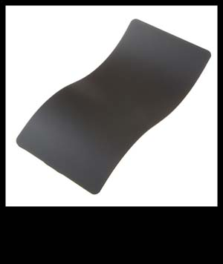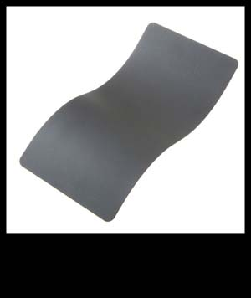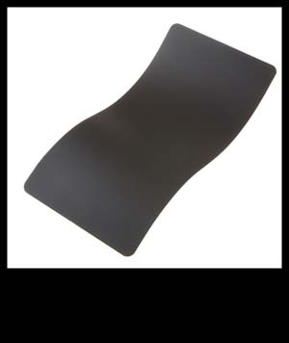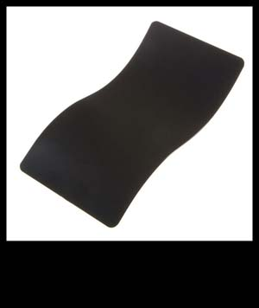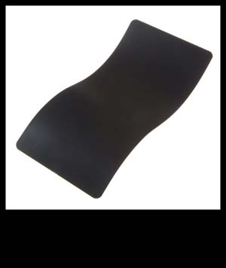
GRAPHITE BLACK SNIPER GREY ARMOR BLACK MIDNIGHT BLUE SOCOM BLUE
H-146 H-234 H-190 H-238 H-130

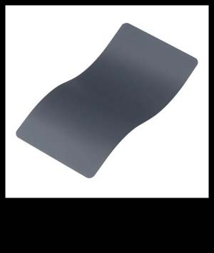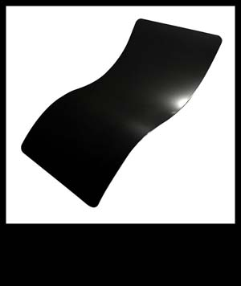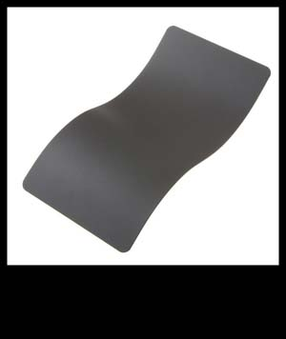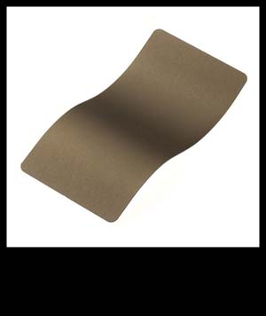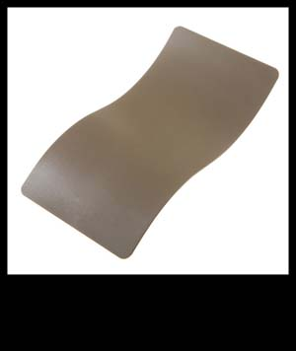
COMBAT GREY GLOSS BLACK MAGPUL STEALTH GREY BURNT BRONZE MAGPUL FLAT DARK EARTH
H-245 H-109 H-188Q H-148 H-267

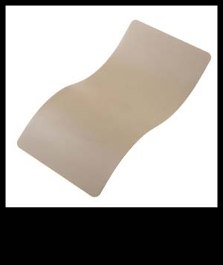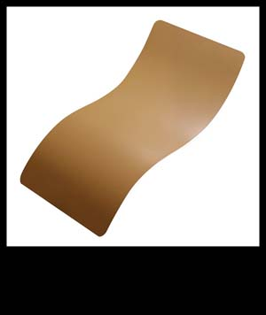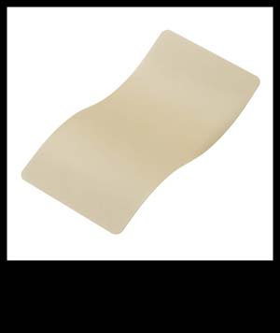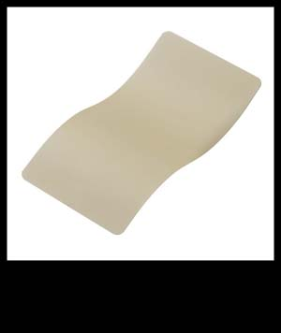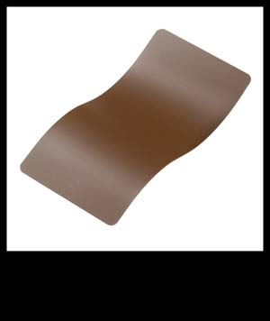
DESERT SAND NOVESKE TIGER EYE BROWN LIGHT SAND BENELLI SAND COPPER BROWN
H-199 H-187Q H-142 H-143 H-149
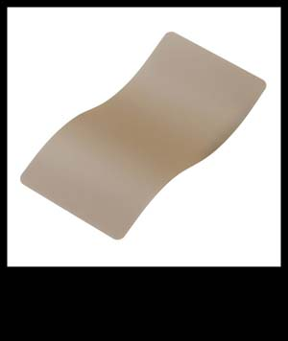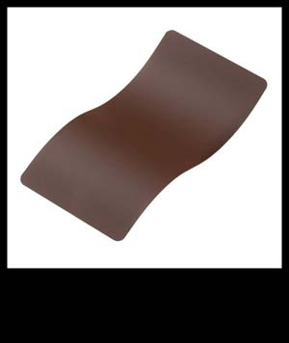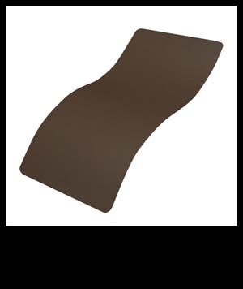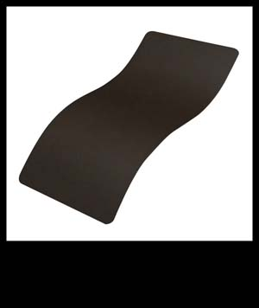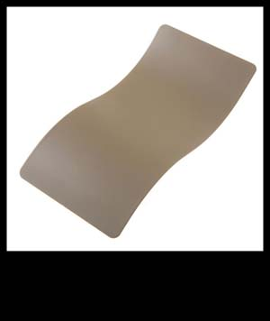
MCMILLAN TAN FEDERAL BROWN MUD BROWN PATRIOT BROWN COYOTE TAN
H-203 H-212Q H-225Q H-226Q H-235

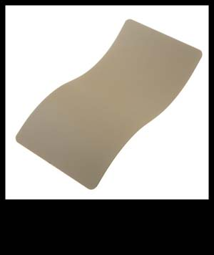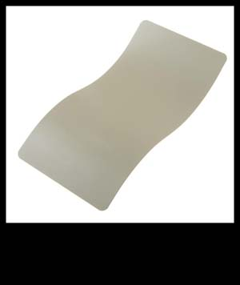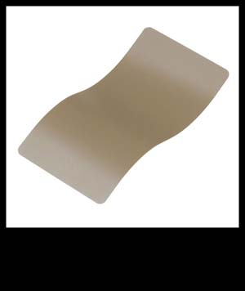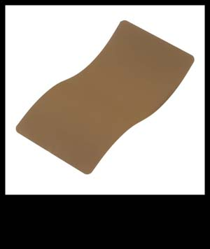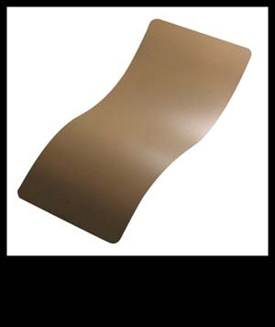
DESERT SAGE DESERT VERDE FLAT DARK EARTH TROY COYOTE TAN BARRETT BROWN
H-247Q H-256Q H-265Q H-268Q H-269Q

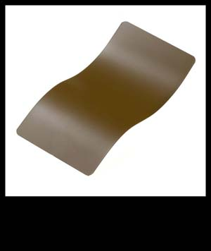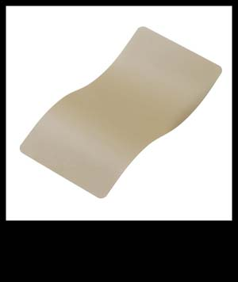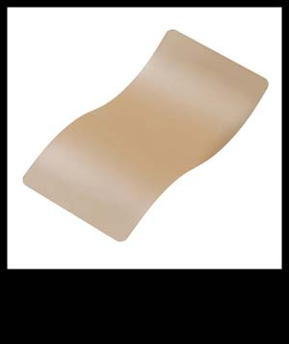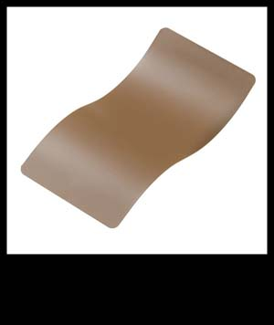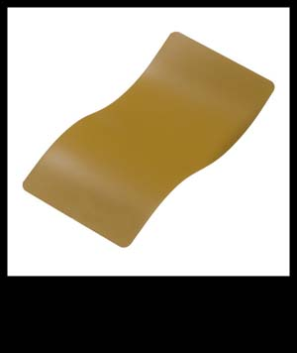
FEDERAL STD FIELD DRAB BROWN SAND FEDERAL STD SABRE SAND MATTE BROWN RAL 8000
H-30118Q H-30372Q H-33446Q H-7504MQ H-8000Q

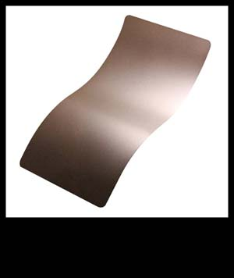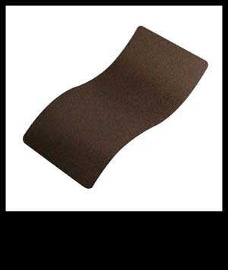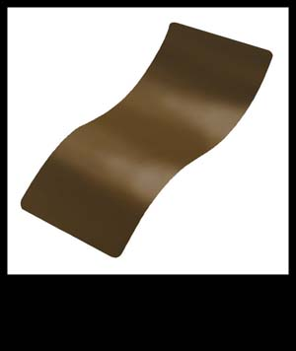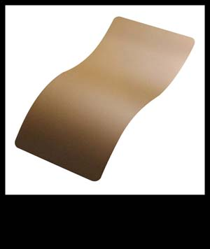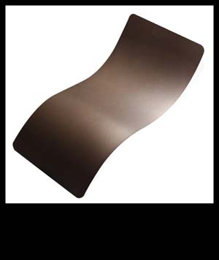
CHOCOLATE BROWN BARRETT BRONZE A.I. DARK EARTH GLOCK EDE MIDNIGHT BRONZE
H-258Q H-259Q H-250Q H-261Q H-294Q

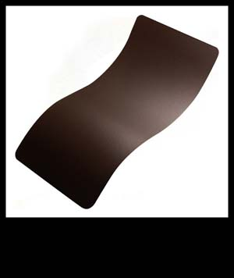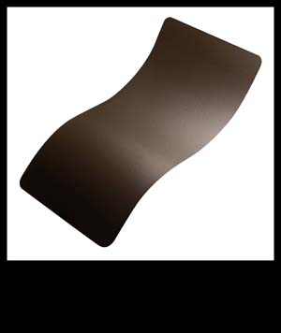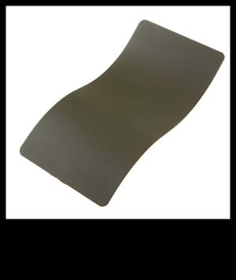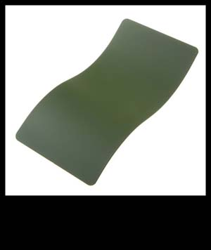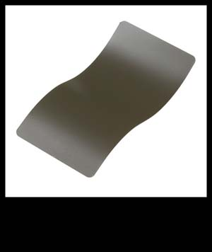
VORTEX BRONZE PLUM BROWN O.D. GREEN HIGHLAND GREEN MAGPUL FOLIAGE GREEN
H-293Q H-298Q H-236Q H200Q H-231Q

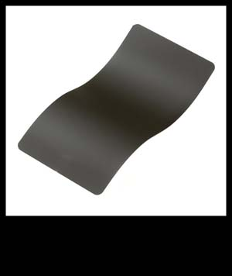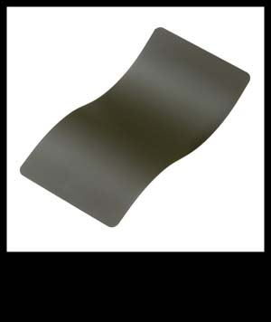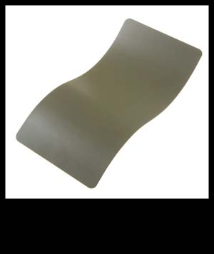
MAGPUL O.D. GREEN MIL SPEC O.D. GREEN DESERT SAGE FOREST GREEN DESERT VERDE
H-232Q H-240Q H-247Q H-248Q H-256Q

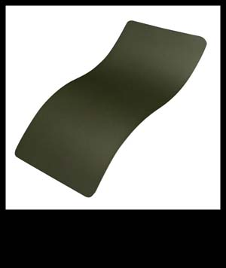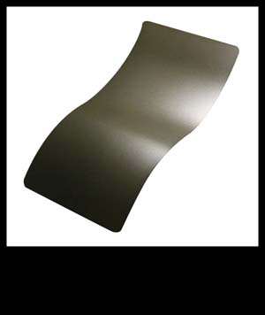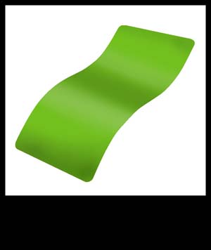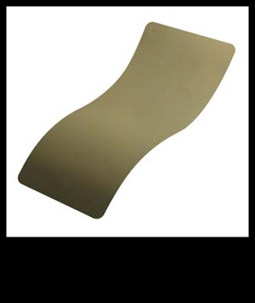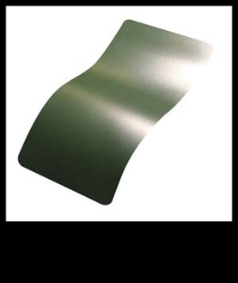
MIL SPEC GREEN SNIPER GREEN ZOMBIE GREEN MULTI CAM GREEN JESSE JAMES EST FRNT GRN
H-264Q H-229Q H-168Q H-204Q H-400Q

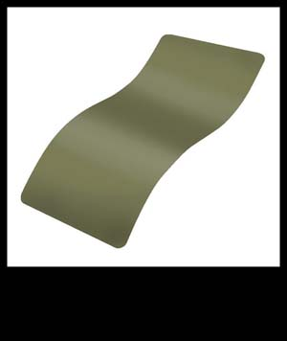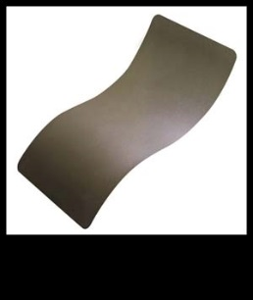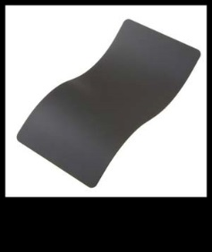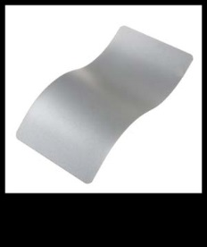
NOVESKE BAZOOKA GRN COLBALT KINETIC GRN SNIPER GREY COLBALT SATIN MAG
H-189Q H-296Q H-234Q H-112Q H-147Q
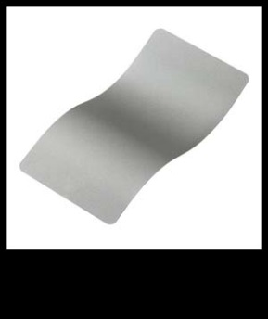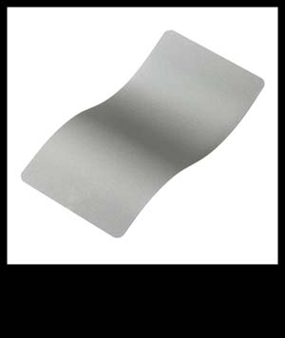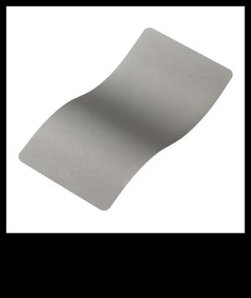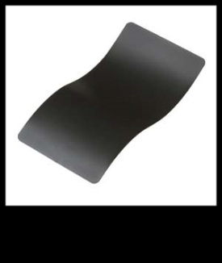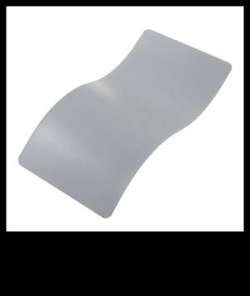
SAVAGE STAINLESS STAINLESS TITANIUM SIG DARK GREY BATTLESHIP GREY
H-150Q H-152Q H-170Q H-210Q H-213Q

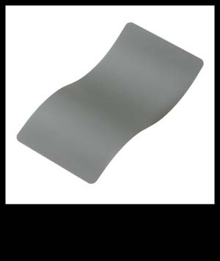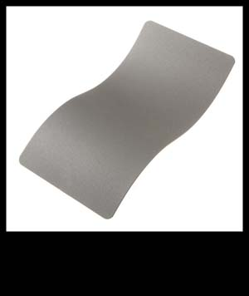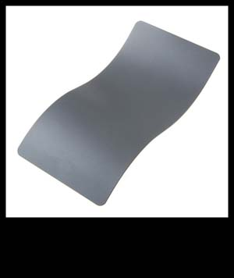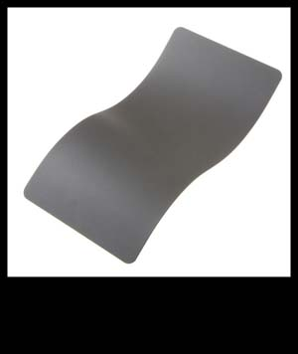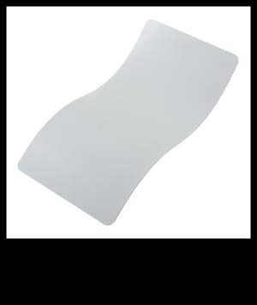
SMITH & WESSON GRY GUN METAL GREY TACTICAL GREY TUNGSTEN HIDDEN WHITE
H-214Q H-219Q H-227Q H-237Q H-242Q

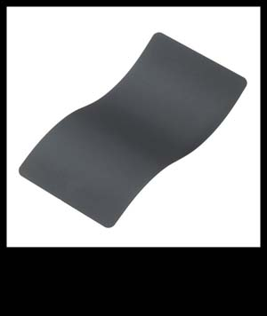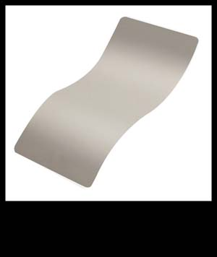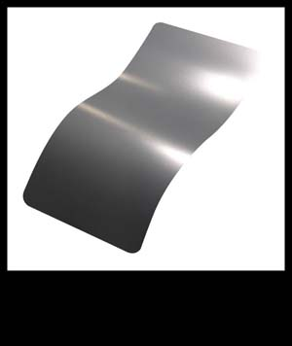
STONE GREY COMBAT GREY STEEL GREY JESSE JAMES CLD WAR GRY MAGPUL STEALTH GRY
H-262Q H-130Q H-139Q H-402Q H-188Q

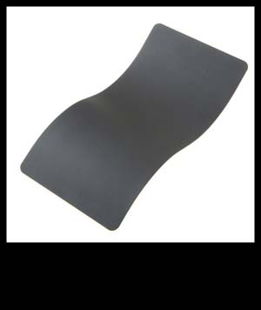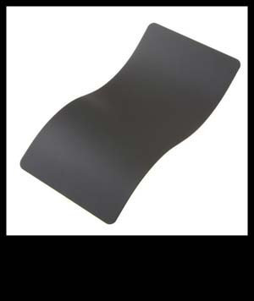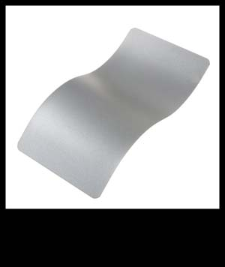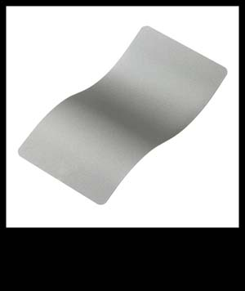
GLOCK GREY COBALT SATIN MAG SAVAGE STAINLESS SATIN ALUMINUM
H-184Q H-112Q H-147Q H-150Q H-151Q

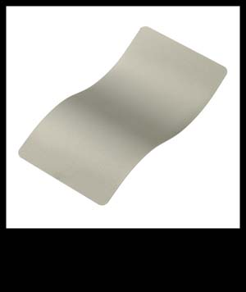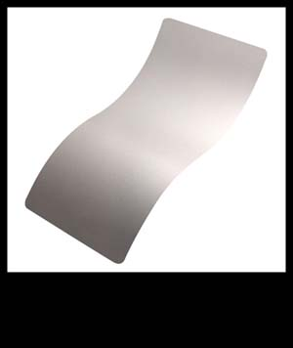
STAINLESS SHIMMER GOLD TITANIUM GUN METAL GREY CRUSHED SILVER
H-152Q H-153Q H-170Q H-219Q H-255Q

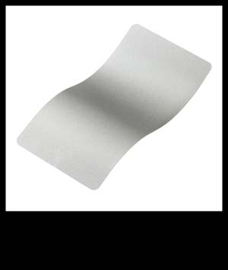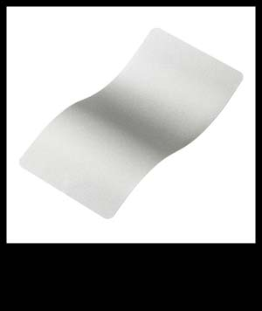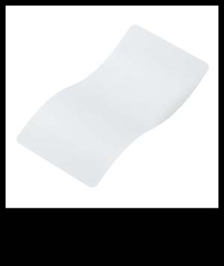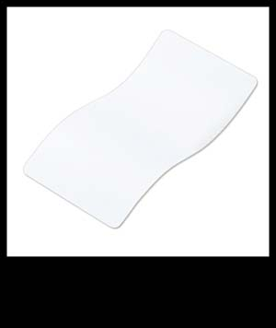
SHIMMER ALUMINUM BRIGHT NICKEL BRIGHT WHITE STORM TROOPER WHITE HIDDEN WHITE
H-158Q H-157Q H-140Q H-297Q H-242Q

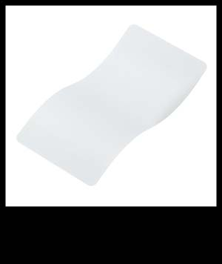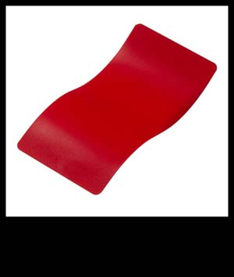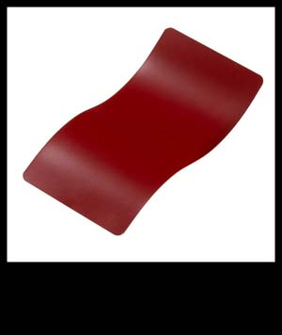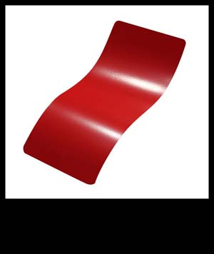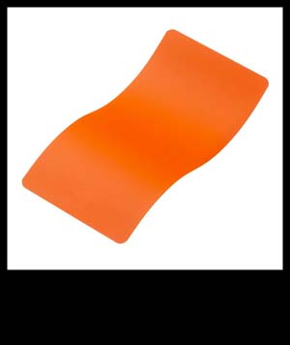
SNOW WHITE SMITH & WESSON RED CRIMSON USMC RED HUNTER ORANGE
H-136Q H-216Q H-221Q H-167Q H-128Q

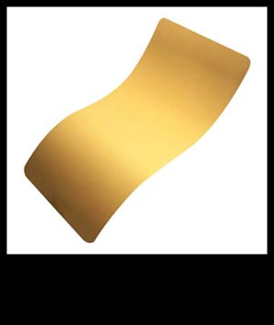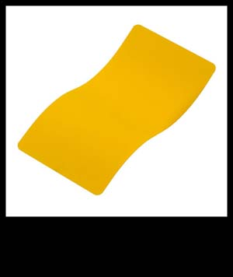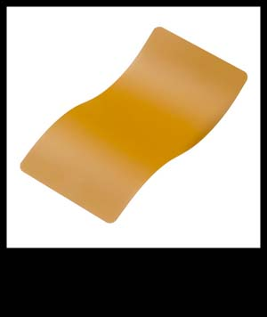
GOLD CORVETTE YELLOW LIGHT SAND SHIMMER GOLD DESERT GOLD
H-122Q H-144Q H-142Q H-153Q H-246Q

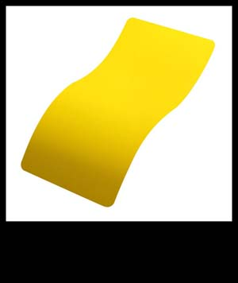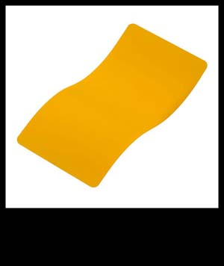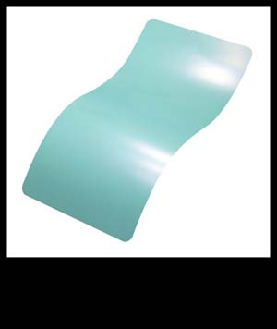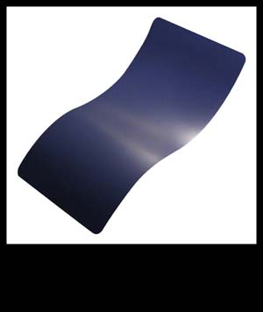
RAL 8000 ELECTRIC YELLOW DEWALT YELLOW ROBIN’S EGG BLUE KEL-TEC NAVY BLUE
H-8000Q H-166Q H-126Q H-175Q H-127Q

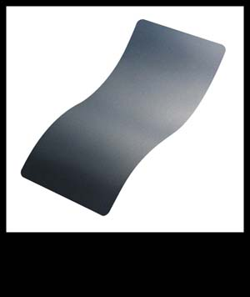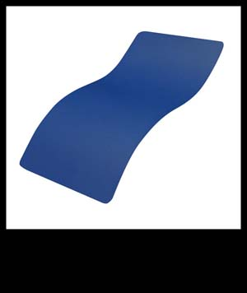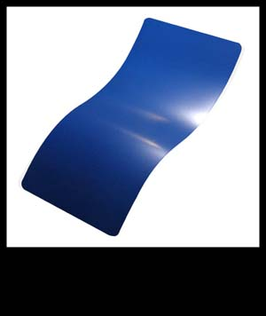
BLUE TITANIUM RIDGEWAY BLUE MIDNIGHT BLUE SOCOM BLUE SKY BLUE
H-185Q H-220Q H-238Q H-245Q H-169Q

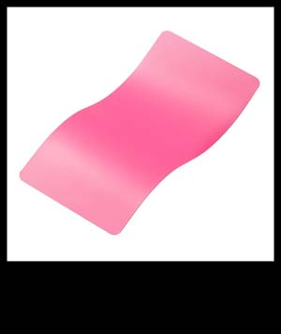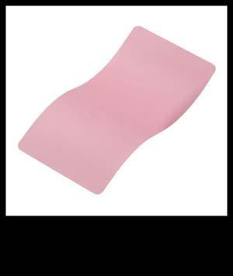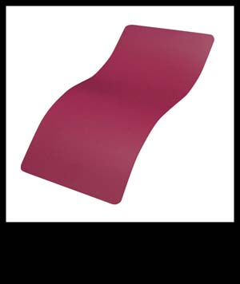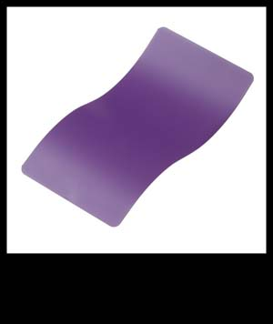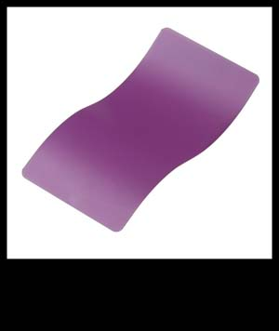
PRISON PINK BAZOOKA PINK SIG PINK BRIGHT PURPLE WILD PURPLE
H-141Q H-244Q H-224Q H-217Q H-197Q

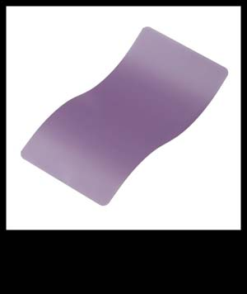
PASTEL PURPLE
H-138Q

HIGH TEMP FIREARM SERIES AIR CURE

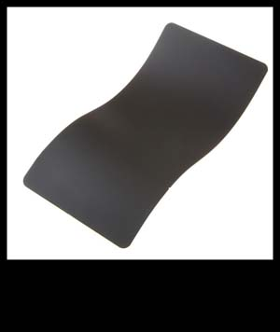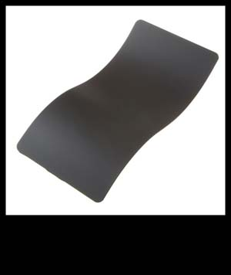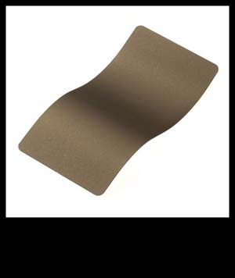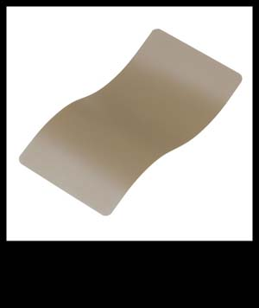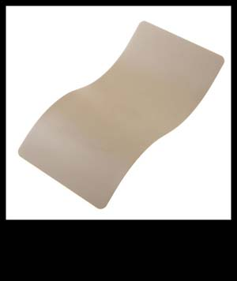
ARMOR BLACK GRAPHITE BLACK BURNT BRONZE FLAT DARK EARTH DESERT SAND
C-190Q C-102Q C-148Q C-246Q C-211Q

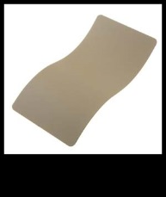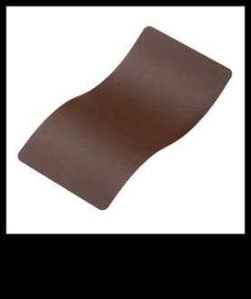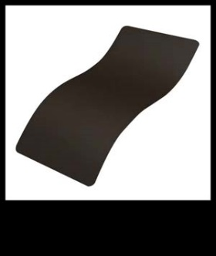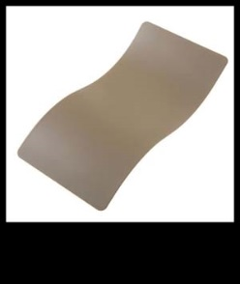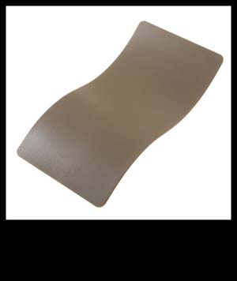
DESERT SAGE FEDERAL BROWN PATRIOT BROWN COYOTE TAN MAGPUL FLAT DARK EARTH
C-212Q C-214Q C-226Q C-240Q C-267Q

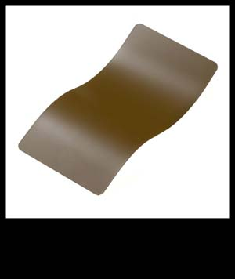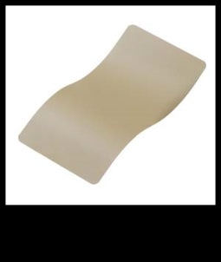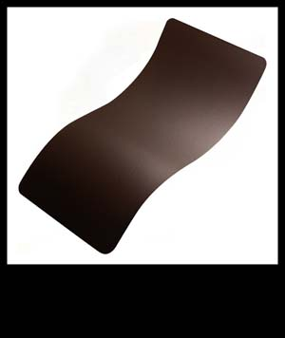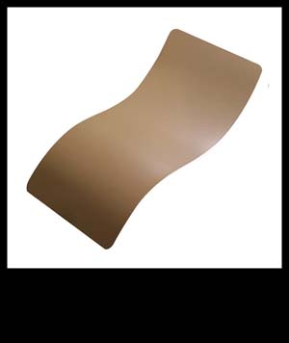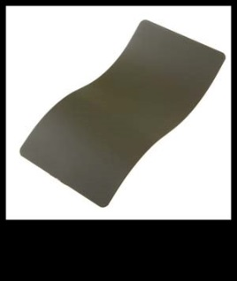
FED STD FIELD DRAB FED STD BRN SAND VORTEX BROWN 20150 O.D. GREEN
C-30118Q C-30372Q C-293Q C-190Q C-241Q

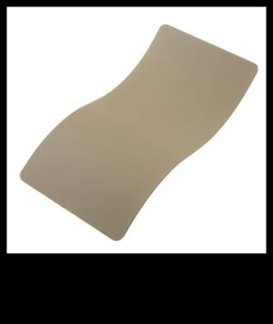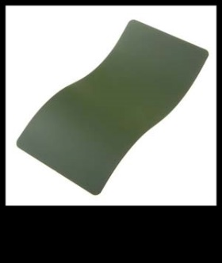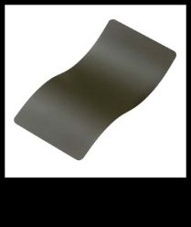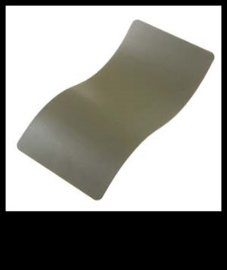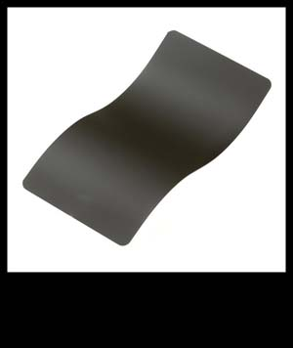
DESERT SAGE HIGHLAND GREEN MIL SPEC O.D. GREEN FOREST GREEN MAGPUL O.D. GREEN
C-212Q C-215Q C-244Q C-248Q C-232Q

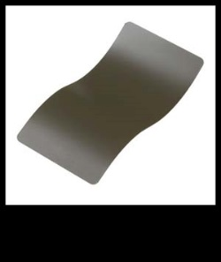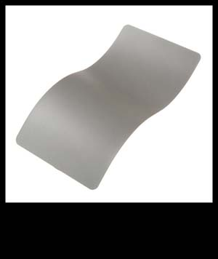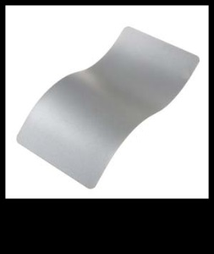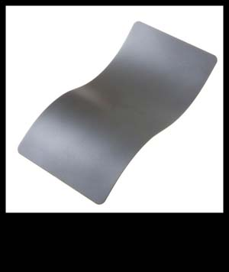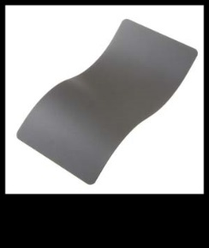
MAGPUL FOLIAGE GRN TITANIUM SATIN MAG MICRO SLK DRY FILM COTNG TUNGSTEN
C-231Q C-105Q C-103Q C-110Q C-111Q

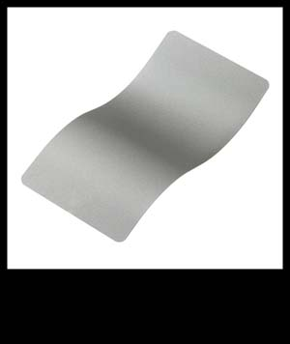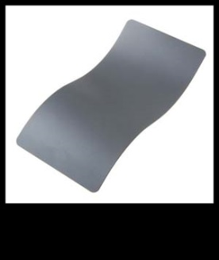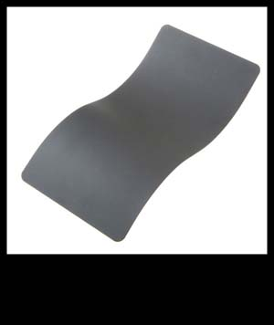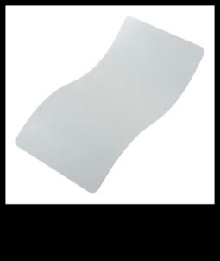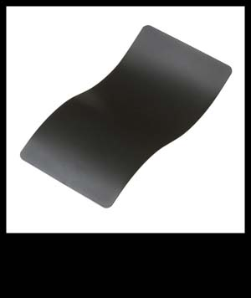
STAINLESS TACTICAL GREY SNIPER GREY HIDDEN WHITE SIG DARK GREY
C-129Q C-228Q C-239Q C-242Q C-209Q

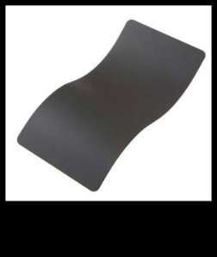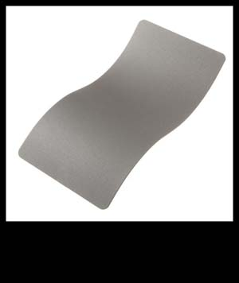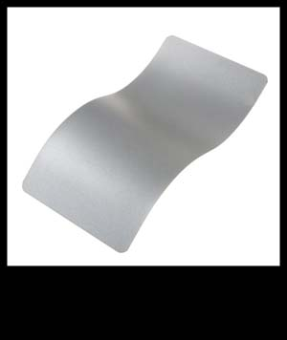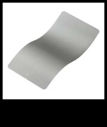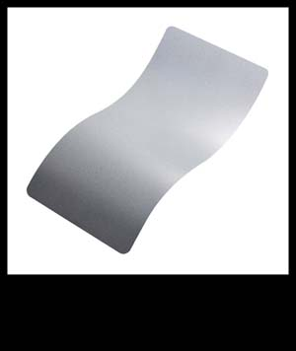
COBALT GUN METAL GREY SATIN MAG STAINLESS SATIN NICKEL
C-112Q C-219Q C-103Q C-129Q C-124Q

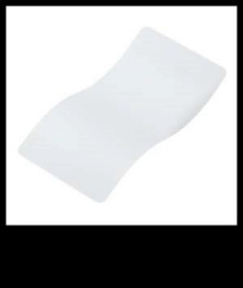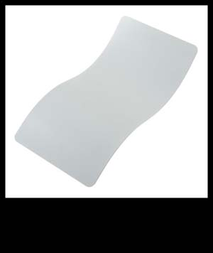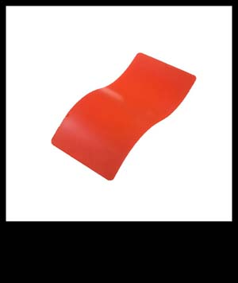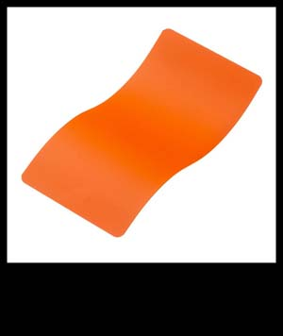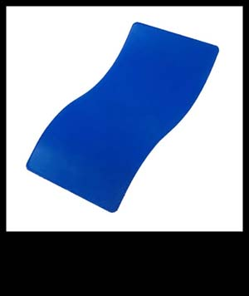
BRIGHT WHITE HIDDEN WHITE STOPLIGHT RED HUNTER ORANGE BLUE FLAME
C-140Q C-242Q C-143Q C-128Q C-158Q

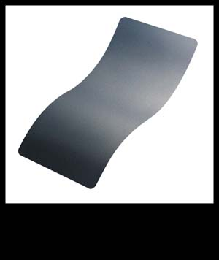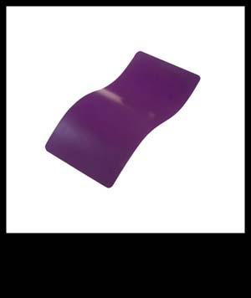
BLUE TITANIUM LOLLYPOP PURPLE
C-189Q C-163Q

PERFORMANCE CLEAR SERIES AIR OR OVEN CURE
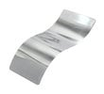
CERAKOTE CLEAR – ALUMINUM MC-5100

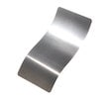
HIGH GLOSS CERAMIC CLEARMC-156 MATTE CERAMIC CLEARMC-157

HIGH GLOSS CERAMIC CLEARMC-160 MATTE CERAMIC CLEARMC-161

HIGH GLOSS ARMOR CLEARH-300 MATTE ARMOR CLEARH-301
CERAKOTE HIGH TEMPERTURE COATINGS OVEN OR AIR CURE
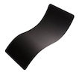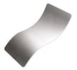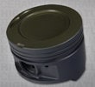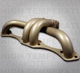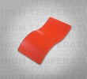
Glacier Black C-7600Q Glacier Silver C-7700Q Piston Coat OC V-136Q Gold OC V-172Q Stoplight Red C-143Q
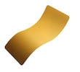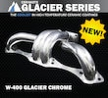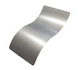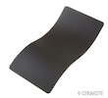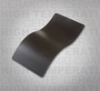
Glacier Gold C-7800Q Glacier Chrome W-400Q Turbine Coat OC V-171Q Jet Black C-138Q Cobra Black V-166Q
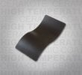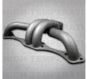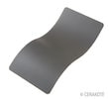
Piston Coat C-186Q Arctic Black OC P-202Q Jet Black OC V-169Q Titanium C-105Q Tungsten OC V-167Q
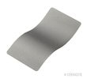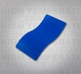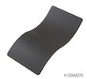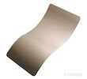
Titanium OC V-164Q Blue Flame C-158Q Cobalt C-112Q Glacier Titanium C-7900Q Tungsten C-111Q
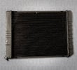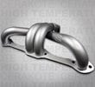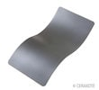
Transfer Grey AC C-187Q Satin Silver OC V-119Q Micro Slick Dry Film Coating C-110Q Glacier Green C-8100Q
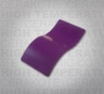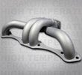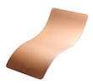
Lollypop Purple C-163Q Satin Nickel C-124Q Cobalt OC V-168Q Titanium Red Piston Coat V-139Q
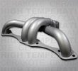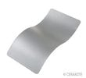
Mag Silver OC V-165Q Electrical Barrier H-900Q Satin Mag C-103Q

